**STORE MANAGER:KEEP TRACKING THE INVENTORY**

|  |  |
| --- | --- |
| **TEAM LEADER** | **NAVEENA T.A** |

**TEAM MEMBERS**

|  |  |
| --- | --- |
| **TEAM MEMBER 1** | NAVEENA T.A |
| **TEAM MEMBER 2** | NISHA BEGUM |
| **TEAM MEMBER 3** | OVIYA |
| **TEAM MEMBER 4** | PRASANNA |

**INTRODUCTION**

A **Store Manager** is a key professional in the retail and business sector, responsible for the overall supervision, direction, and performance of a store. Acting as both a leader and a strategist, the store manager ensures that the store runs efficiently while meeting organizational goals and delivering high-quality customer service.

The role of a store manager is **multifaceted**—they handle staff management, inventory control, merchandising, customer relations, budgeting, and compliance with company policies. They act as the main point of contact between the store employees and higher management, ensuring smooth communication and effective execution of business strategies.

One of the core responsibilities of a store manager is **team leadership**. They recruit, train, and motivate staff members, assign duties, monitor performance, and create a positive work culture that boosts productivity. Additionally, they are accountable for setting sales targets, monitoring key performance indicators (KPIs), and implementing promotional campaigns to drive revenue.

From an operational standpoint, store managers play a vital role in **inventory and stock management**, ensuring that products are available, properly displayed, and well-maintained. They also resolve customer complaints, improve service quality, and ensure that shoppers have a seamless and satisfying experience.

In today’s retail environment, a store manager’s role has evolved beyond basic supervision. With the rise of competition, digital transformation, and customer expectations, store managers are required to be **adaptable, analytical, and innovative**. They not only manage day-to-day activities but also take part in strategic planning, financial analysis, and customer engagement to strengthen the store’s position in the market.

Ultimately, a successful store manager contributes significantly to the store’s **profitability, reputation, and long-term sustainability**. Their leadership directly influences employee satisfaction, customer loyalty, and overall business growth.

**PROJECT** **OVERVIEW**.

* It enables efficient **inventory management**, ensuring that stock levels are tracked, shortages are prevented, and excess storage is minimized.
* Provides a platform for **employee management**, including assigning tasks, monitoring performance, and scheduling shifts.
* Ensures **customer satisfaction** through quick billing, proper complaint handling, and maintaining service quality.
* Includes **sales tracking and reporting**, helping managers analyze trends, set sales targets, and make data-driven decisions.
* Offers **financial management tools** such as expense tracking, budget planning, and profit analysis.
* Helps in **implementing promotional campaigns** and monitoring their effectiveness.
* Improves **communication between higher management and staff**, ensuring policies and business goals are implemented effectively.
* Ultimately, the project aims to **enhance operational efficiency, increase profitability, and improve customer loyalty**.

**OBJECTIVE**

* To streamline and automate store operations for improved efficiency.
* To manage inventory effectively and reduce stockouts or overstocking.
* To improve employee productivity through proper scheduling and task allocation.
* To enhance customer satisfaction with better service and quick response.
* To track and analyze sales performance for informed decision-making.
* To ensure proper financial management and profitability of the store.
* To bridge the communication gap between management, staff, and customers.
* To implement promotional activities and monitor their success.
* To maintain compliance with company policies and security standards.

**FEATURES**

* **Inventory Management** – Real-time tracking of stock levels, product categorization, and alerts for low stock.
* **Employee Management** – Staff scheduling, task assignment, and performance tracking.
* **Customer Management** – Recording customer details, handling complaints, and ensuring loyalty programs.
* **Sales & Billing System** – Fast and accurate billing with integrated sales tracking.
* **Reports & Analytics** – Generate detailed sales, expense, and profit reports for decision-making.
* **Financial Management** – Expense tracking, budget control, and revenue monitoring.
* **Promotions & Discounts** – Managing offers, discounts, and seasonal campaigns.
* **Security Features** – Role-based access control, secure transactions, and data protection.
* **User-Friendly Dashboard** – Centralized control panel for quick access to all store operations.
* **Multi-Device Access** – Can be operated through computer systems, POS devices, or mobile applications.

**TOOL & TECHOLOGIES USE**

**Frontend Technologies**

* + HTML, CSS, JavaScript – For designing the user interface.
  + React.js / Angular / Vue.js – For building interactive and dynamic dashboards.
  + Bootstrap / Tailwind CSS – For responsive and attractive UI design.

**Backend Technologies**

* + Node.js / Express.js – For handling server-side logic and APIs.
  + Java / Spring Boot – Alternative backend framework for enterprise-level apps.
  + Python / Django / Flask – For flexible and fast backend development.

**Database**

* + MySQL / PostgreSQL – For structured data storage and transaction management.
  + MongoDB – For NoSQL-based scalable storage of store and customer data.

**Authentication & Security**

* + JWT (JSON Web Token) / OAuth – For secure login and role-based access.
  + SSL Encryption – To ensure safe transactions and protect customer data.

**Development Tools**

* + Git & GitHub – For version control and collaboration.
  + VS Code / IntelliJ / PyCharm – As IDEs for coding and debugging.
  + Postman – For testing APIs.

**Reporting & Analytics**

* + Chart.js / Recharts / Power BI – For visualizing sales and performance data.

**Deployment**

* + Docker – For containerized deployment.
  + AWS / Azure / Google Cloud – For cloud hosting and scalability.
  + Netlify / Vercel / Heroku – For web app deployment.

**Other Tools**

* + Firebase – For real-time database and authentication.
  + Stripe / PayPal API – For secure online payment integration.
  + Jira / Trello – For project management and task tracking.

**COMPONENT STRUCTURE**

* **Dashboard Component**
  + Centralized panel showing sales summary, stock alerts, revenue charts, and notifications.
* **Inventory Management Component**
  + Add, update, delete, and track products.
  + Stock monitoring with low-stock alerts and category-wise management.
* **Employee Management Component**
  + Staff profiles, attendance, shift scheduling, and task assignment.
  + Performance tracking and role-based access control.
* **Customer Management Component**
  + Customer records, purchase history, loyalty programs, and complaint handling.
* **Sales & Billing Component**
  + POS (Point of Sale) system for generating bills.
  + Discounts, offers, and payment integration.
* **Reports & Analytics Component**
  + Sales trends, revenue reports, and expense analysis.
  + Exportable reports (PDF, Excel).
* **Financial Management Component**
  + Expense tracking, budget planning, and profit calculation.
* **Promotions & Campaign Component**
  + Manage seasonal discounts, promotional offers, and track effectiveness.
* **Authentication & Security Component**
  + User login, signup, and role-based permissions (admin, staff, cashier).
* **Settings Component**
  + Store configuration, tax setup, currency, and system preferences.
* **Notification Component**
  + Alerts for stockouts, upcoming offers, low sales, or staff reminders.

**STATE MANAGEMENT**

• Maintains a centralized state to handle data consistency across all components (e.g., inventory, sales, employees).

• Manages user authentication states (logged in, logged out, role-based access).

• Handles UI states like loading indicators, error messages, and success notifications.

• Supports cart and billing states in the POS system to ensure accurate transactions.

• Tracks employee activity states (active, on-shift, off-shift).

• Maintains reporting states, ensuring updated analytics without reloading the entire app.

• Improves performance by avoiding unnecessary re-renders through optimized state updates.

• Provides data flow management between components, ensuring smooth communication.

• Can be implemented using tools like Redux, Context API, MobX, or Vuex depending on the technology stack.

**SETUP INSTRUCTION**

* **Prerequisites**
  + Install **Node.js** (for running backend and frontend dependencies).
  + Install **npm** or **yarn** package manager.
  + Install **MySQL / MongoDB** for database setup.
  + Install **Git** for version control.
  + Recommended IDE: **VS Code**.
* **Clone the Project**
  + Open terminal/command prompt.
  + Run:
  + git clone <repository-link>
  + cd store-manager
* **Backend Setup**
  + Navigate to the backend folder:
  + cd backend
  + Install dependencies:
  + npm install
  + Configure database in .env (e.g., DB name, username, password, port).
  + Run backend server:
  + npm start
* **Frontend Setup**
  + Navigate to the frontend folder:
  + cd store-management-frontend
  + Install dependencies:
  + npm install
  + Start development server:
  + npm run dev # (or npm start depending on config)
* **Database Setup**
  + Create database manually in MySQL/MongoDB.
  + Run migration/seed commands if provided:
  + npm run migrate
  + npm run seed
* **Run the Application**
  + Open browser and go to:
  + http://localhost:3000
* **Build for Production**
  + Frontend:
  + npm run build
  + Deploy on hosting services like **Heroku, AWS, Netlify, or Vercel**.
* **Additional Setup**
  + Configure environment variables (.env) for API keys, authentication, and payment gateways.
  + Set up role-based access (Admin, Manager, Staff).
  + Enable SSL/HTTPS for secure deployment.

**INSTALLATION**

* **Node.js & npm**: Install Node.js (which comes with npm) for running the application and managing dependencies.
  + Installation instructions: <https://nodejs.org/en/download/package-manager/>
* **React.js**: React.js is a popular JavaScript library for building user interfaces.
  + It enables developers to create interactive and reusable UI components, making it easier to build dynamic and responsive web applications.
  + Install React.js, a JavaScript library for building user interfaces.
  + Create a new React app:
  + npx create-react-app store-manager

Replace **store-manager** with your preferred project name.

* **Navigate to the project directory**:
* cd store-manager
* **Running the React App**: With the React app created, you can now start the development server and see your Store Manager application in action.
* **Start the development server**:
* npm start

This command launches the development server, and you can access your Store Manager app at [**http://localhost:3000**](http://localhost:3000) in your web browser.

* **Backend Setup (Optional)**: If your Store Manager project includes a backend:
  + Navigate to backend folder:
  + cd backend
  + npm install
  + npm start
* **Database Setup**:
  + Install **MySQL** or **MongoDB** for data storage.
  + Create a new database for Store Manager.
  + Configure database details in .env file (username, password, DB name, port).
* **Basic Technologies Knowledge Required**:
  + **HTML, CSS, and JavaScript**: Essential for structure, styling, and interactivity of the app.
  + **Version Control (Git)**: Use Git for version control, enabling collaboration and tracking changes throughout the development process.
  + Platforms like **GitHub** or **Bitbucket** can host your repository.
* **Git**: Download and installation instructions: <https://git-scm.com/downloads>
* **Development Environment**: Choose a code editor or Integrated Development Environment (IDE) that suits your preferences:

**Visual Studio Code**: <https://code.visualstudio.com/download>

**Sublime Text**: <https://www.sublimetext.com/download>

**WebStorm**: <https://www.jetbrains.com/webstorm/>

* **To clone and run the Store Manager project from GitHub**:
* Open terminal and run:
* git clone <repository-link>
* cd store-manager
* **Install Dependencies**:
* npm install
* **Start the development server**:
* npm start
* **Access the Application**: Open your browser and go to:
* http://localhost:3000

**RUNNING THE APPLICATION**

* **Start the Backend Server** (if your project has a backend):
  + Navigate to the backend folder:
  + cd backend
  + npm start
  + The backend server will run on the configured port (e.g., [**http://localhost:5000**](http://localhost:5000)).
* **Start the Frontend Server**:
  + Navigate to the frontend folder (or project root if frontend only):
  + cd store-manager
  + npm start
  + This command launches the React development server.
* **Access the Application**:
  + Open your web browser and visit:
  + http://localhost:3000
  + You should now see the **Store Manager dashboard**.
* **Login / Authentication**:
  + Use the provided credentials (e.g., Admin / Manager login) or register a new user.
* **Test Core Features**:
  + Add, update, and delete products in the **Inventory**.
  + Process a sale using the **Billing/POS system**.
  + View reports in the **Analytics/Reports section**.
  + Manage employees, customers, and promotions as per project setup.
* **Stop the Application**:
  + Press CTRL + C in the terminal to stop either backend or frontend servers.
* **Optional – Build for Production**:
  + To create an optimized build of the Store Manager app:
  + npm run build
  + Deploy the build files to a server or hosting service (e.g., **Netlify, Vercel, AWS, Heroku**).

**COMPONENT DOCUMENTATION**

• **Dashboard Component**

* Displays an overview of sales, revenue, stock alerts, and notifications.
* Provides quick access to major features like inventory, billing, and reports.

• **Inventory Management Component**

* Allows adding, updating, deleting, and searching products.
* Tracks stock levels and triggers low-stock alerts.
* Supports product categorization for easy management.

• **Employee Management Component**

* Maintains employee details (name, role, shift, performance).
* Enables task assignment and shift scheduling.
* Provides role-based access control (Admin, Manager, Staff).

• **Customer Management Component**

* Stores customer profiles, purchase history, and loyalty details.
* Handles feedback and complaint resolution.
* Supports discount eligibility and promotional offers.

• **Sales & Billing Component**

* POS system for creating invoices and processing payments.
* Handles discounts, taxes, and multiple payment options.
* Updates stock automatically after each sale.

• **Reports & Analytics Component**

* Generates sales reports, revenue charts, and expense summaries.
* Provides downloadable reports (Excel, PDF).
* Helps in decision-making through data visualization.

• **Financial Management Component**

* Tracks expenses, revenue, and profit margins.
* Helps in budget planning and cost control.
* Provides financial summaries for management review.

• **Promotions & Campaign Component**

* Allows adding seasonal offers, coupons, and discounts.
* Tracks performance of campaigns through sales impact.

• **Authentication & Security Component**

* Provides secure login and registration functionality.
* Ensures role-based authorization (Admin, Manager, Cashier).
* Manages session handling and logout.

• **Settings Component**

* Enables store configuration (tax rates, currency, invoice settings).
* Allows theme customization and system preferences.

• **Notification Component**

* Sends alerts for low stock, pending payments, or staff reminders.
* Supports email/SMS notifications (optional integration).

**REUSABLE COMPONENTS**

* **Header / Navbar Component**
  + Used across all pages for navigation (Dashboard, Inventory, Sales, Reports, etc.).
  + Can include user profile, notifications, and logout button.
* **Sidebar / Menu Component**
  + Provides quick navigation links.
  + Reusable in admin, manager, and cashier views.
* **Button Component**
  + Standardized design for all buttons (e.g., Add, Edit, Delete, Save).
  + Supports variations (primary, secondary, danger).
* **Form Component**
  + Reusable form structure for adding/editing products, employees, and customers.
  + Includes input fields, dropdowns, validation, and submit actions.
* **Table Component**
  + Used for displaying lists (products, employees, customers, sales history).
  + Supports sorting, searching, and pagination.
* **Modal / Popup Component**
  + Used for confirmation dialogs (e.g., Delete confirmation, Edit details).
  + Can also be used for quick data entry without leaving the page.
* **Card Component**
  + Displays summarized information like daily sales, stock alerts, or revenue.
  + Used in Dashboard and Reports.
* **Notification / Alert Component**
  + Reusable for showing success, error, and warning messages.
  + Used across Inventory, Billing, and Employee modules.
* **Input Field Component**
  + Standard input design for text, number, date, and password fields.
  + Ensures consistent styling and validation.
* **Chart Component**
  + Displays sales trends, revenue breakdown, and analytics.
  + Can be reused in Reports, Dashboard, and Campaign modules.

**STYLING**

* **Consistent Theme**
  + Use a uniform color scheme across all pages (e.g., primary color for buttons, secondary for highlights).
  + Maintain consistent fonts and typography for headings, subheadings, and body text.
* **Responsive Design**
  + Ensure the application works seamlessly on desktop, tablet, and mobile devices.
  + Use CSS frameworks like **Bootstrap** or **Tailwind CSS** for responsive layouts.
* **Reusable Styles**
  + Define global CSS classes for common UI elements (buttons, forms, tables).
  + Use component-level styling (CSS modules, styled-components) to avoid duplication.
* **Dashboard & Cards**
  + Use card-based layouts with soft shadows and rounded corners for modern UI.
  + Display statistics (sales, revenue, stock alerts) with different colors/icons.
* **Tables & Forms**
  + Style tables with alternating row colors for readability.
  + Use clear labels, input validations, and error messages in forms.
* **Navigation (Header & Sidebar)**
  + Keep the navbar fixed at the top or sidebar for easy navigation.
  + Highlight active menu items for better user experience.
* **Icons & Visuals**
  + Use icon libraries like **FontAwesome** or **Lucide** for buttons, menus, and alerts.
  + Add visuals (charts, graphs) for sales and reports instead of plain text.
* **Light & Dark Mode (Optional)**
  + Provide theme-switching for better user accessibility.
  + Store user preference in local storage.
* **Accessibility**
  + Use proper contrast ratios for text and background.
  + Ensure buttons and links are keyboard-navigable.
* **Animations & Transitions**
  + Add smooth hover effects for buttons and links.
  + Use subtle transitions for modals, dropdowns, and notifications.

**ARCHITECTURE**

* **Layered Architecture**
  + Application divided into **Frontend, Backend, and Database** layers for modularity and scalability.
* **Frontend (Presentation Layer)**
  + Built using **React.js** for interactive UI.
  + Handles user interactions, form submissions, and data visualization (tables, charts).
  + Implements **state management** (Redux / Context API) for consistency across components.
* **Backend (Application Layer)**
  + Developed with **Node.js + Express.js** (or alternative frameworks like Django / Spring Boot).
  + Provides APIs for handling business logic (inventory, sales, customers, employees).
  + Ensures role-based access control (Admin, Manager, Cashier).
* **Database Layer**
  + Uses **MySQL / MongoDB** for data storage.
  + Stores information about products, employees, customers, sales, and reports.
  + Supports CRUD operations with data validation and security.
* **API Communication**
  + RESTful APIs connect frontend and backend.
  + JSON used for structured data exchange.
* **Authentication & Security**
  + JWT/OAuth used for secure login and session management.
  + Passwords stored securely using encryption (bcrypt/argon2).
* **Reporting & Analytics Module**
  + Generates reports from the database (sales trends, expenses, stock levels).
  + Provides data visualization via charts/graphs.
* **Scalability & Modularity**
  + Modular architecture allows adding new features (loyalty programs, promotions, payments) without affecting core modules.
  + Can be scaled horizontally (multiple servers) or vertically (database optimization).
* **Error Handling & Logging**
  + Centralized error handling at the backend.
  + Logging mechanisms to track issues and improve debugging.
* **Deployment Architecture**
  + Frontend deployed on **Netlify/Vercel**.
  + Backend deployed on **Heroku/AWS/Azure**.
  + Database hosted on **Cloud DB services** (MongoDB Atlas, AWS RDS, etc.).

**TESTING**

• **Unit Testing**

* Test individual components like Inventory, Billing, and Employee modules.
* Ensure that functions (e.g., add product, generate bill) return expected results.

• **Integration Testing**

* Verify the interaction between frontend and backend APIs.
* Test whether data flows correctly from database → backend → frontend (e.g., product stock update after a sale).

• **Functional Testing**

* Check if all features (add/edit/delete inventory, billing, employee management) work as per requirements.
* Validate user roles (Admin, Manager, Staff) have correct permissions.

• **UI/UX Testing**

* Ensure the interface is user-friendly and consistent across pages.
* Test responsiveness on desktop, tablet, and mobile.

• **Performance Testing**

* Measure system response time under normal and peak loads (e.g., multiple sales at once).
* Check database queries for efficiency.

• **Security Testing**

* Test authentication (login/logout) and role-based access control.
* Validate secure storage of sensitive data (passwords, transactions).

• **Cross-Browser & Device Testing**

* Run the app on multiple browsers (Chrome, Edge, Firefox) and devices (Windows, macOS, Android, iOS).

• **Error Handling Testing**

* Verify system response to invalid inputs (e.g., negative stock, wrong login credentials).
* Ensure proper error messages are displayed.

• **Regression Testing**

* After new updates, test old features to ensure they are still working.

• **User Acceptance Testing (UAT)**

* Get feedback from actual users (store managers, staff) to confirm that the system meets real-world requirements

**FOLDER STRUCTURE**

• **frontend/** → Handles the user interface (React.js).

* **public/** → Static files like index.html, images, and icons.
* **src/assets/** → Images, logos, and fonts.
* **src/components/** → Reusable UI components (Navbar, Sidebar, Buttons, Tables, Forms).
* **src/pages/** → Screens/pages like Dashboard, Inventory, Sales, Employees, Reports.
* **src/context/** → State management (Context API or Redux store).
* **src/services/** → API call functions (Axios/Fetch).
* **src/utils/** → Helper utilities (formatters, validators).
* **src/styles/** → Global CSS/Tailwind/Styling files.
* **App.js** → Root component.
* **index.js** → React app entry point.

• **backend/** → Manages business logic & APIs (Node.js + Express).

* **config/** → Database configuration, environment setup.
* **controllers/** → Handles business logic (inventory, sales, employees, customers).
* **models/** → Database models (Product, Employee, Customer, Sales).
* **routes/** → API endpoints.
* **middlewares/** → Authentication, authorization, error handling.
* **utils/** → Helper functions (logging, validation).
* **server.js** → Entry point of backend server.

• **database/** → Database scripts and schema.

* **migrations/** → Database schema creation scripts.
* **seeders/** → Sample/test data for database.
* **schema.sql** → Main database schema file.

• **docs/** → Project documentation and diagrams.

* Architecture diagrams, setup instructions, user manual.

• **.env** → Environment variables (DB credentials, API keys, etc.).

• **README.md** → Project overview & setup instructions.

• **package.json** → Project dependencies (frontend & backend).

**FIGURE 1:**

PROJECR STRUCTURE PANEL

**SCREENSHOTS OR DEMO IMAGES**

FIGURE 2:

HOME PAGE

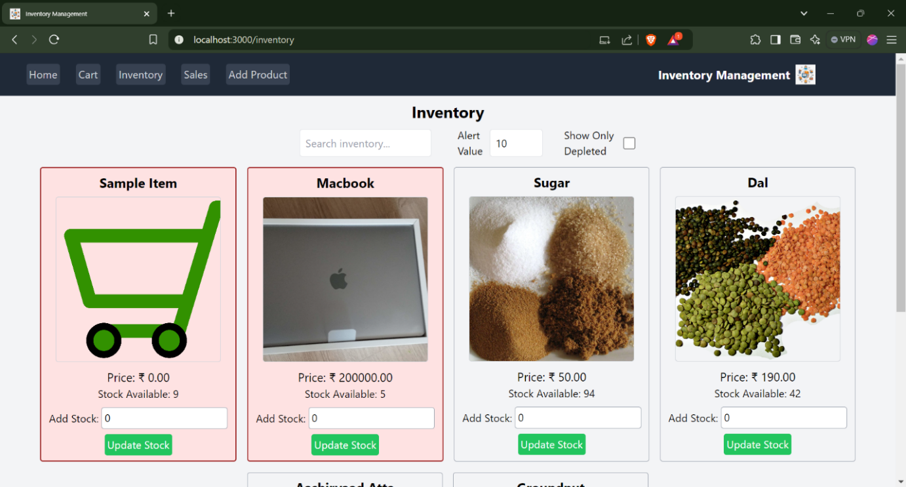

**FIGURE 3:**

**CART PAGE**

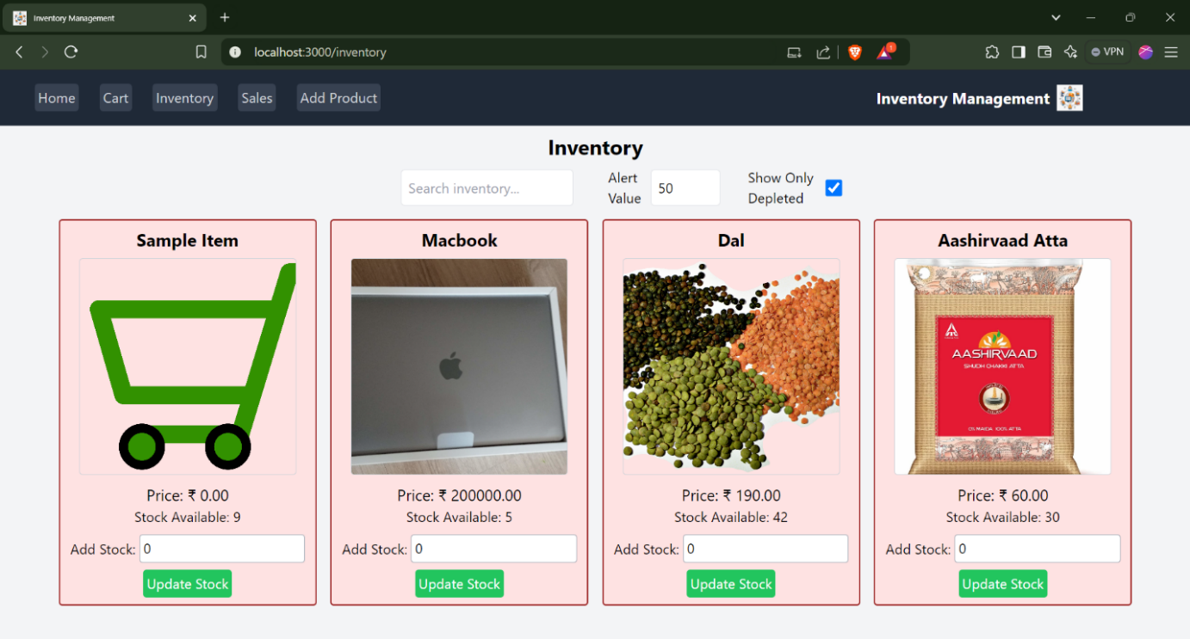

**FIGURE 4:**

**INVENTORY PAGE**

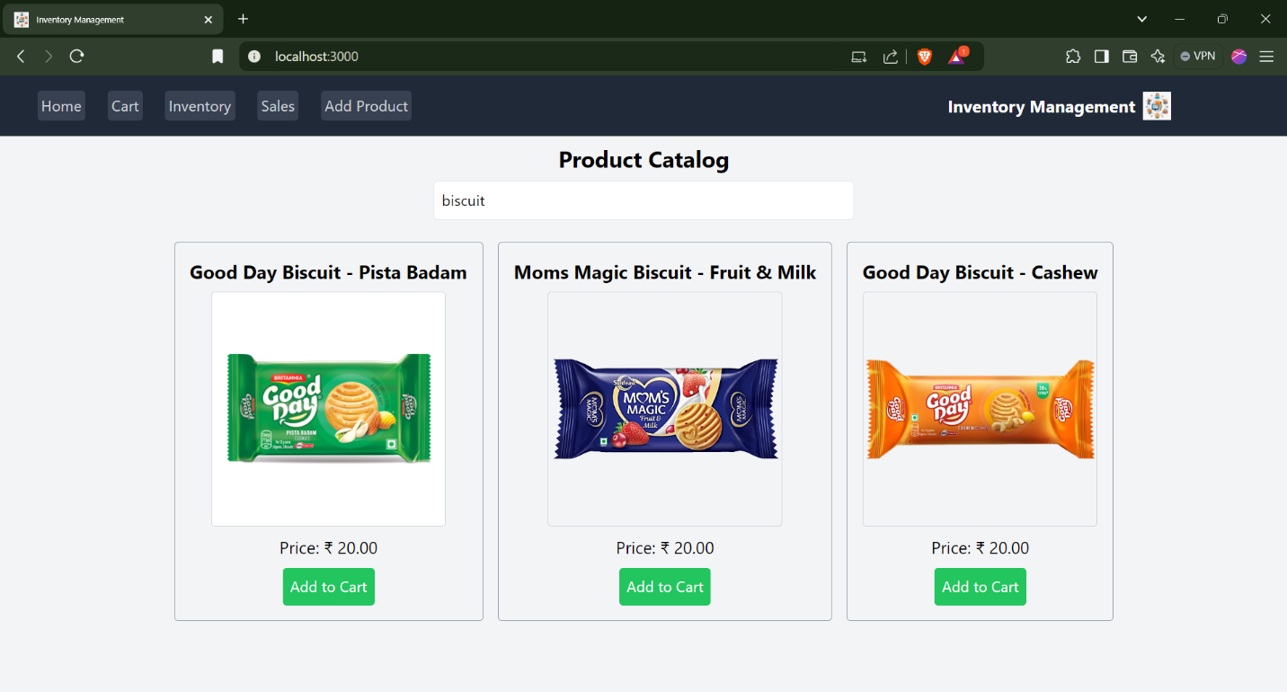

**FIGURE 5:**

**PRODUCT CATOLOG PAGE**

**FIGURE 6:**

**ADD A NEW PRODUCT PAGE**

**KNOWN ISSUES**

**• Cross-Browser Compatibility**

* Minor UI alignment issues may appear on older browsers like Internet Explorer.

**• Mobile Responsiveness**

* Some pages may not render perfectly on very small screens or older mobile devices.

**• Performance Lag**

* Slower response when handling very large datasets (e.g., thousands of products or transactions).

**• Data Validation**

* Limited input validation in some forms; may allow incorrect formats if users bypass frontend validation.

**• Authentication & Security**

* Session timeout and token refresh are not fully optimized.
* Password recovery/reset feature may be missing or basic.

**• Reporting/Analytics**

* Generating reports with very large data may take longer.
* Some chart components may not scale properly for extreme data values.

**• Error Handling**

* Backend may return generic error messages in some edge cases instead of detailed errors.

**• Feature Limitations**

* Loyalty program, multi-store support, and advanced promotional features may not be implemented.

**• Integration Issues**

* Payment gateway or email notification integration may require manual configuration.

**FUTURE ENHANCEMENT**

• **Multi-Store Support**

* Manage inventory, employees, and sales for multiple store locations from a single system.

• **Advanced Reporting & Analytics**

* Include predictive analytics, sales forecasting, and trend analysis using AI/ML.

• **Mobile Application**

* Develop a mobile app version for on-the-go management and monitoring.

• **Loyalty Programs & Customer Rewards**

* Implement points, rewards, and membership benefits for repeat customers.

• **Integration with Payment Gateways**

* Enable online payments, digital wallets, and seamless POS integration.

• **Real-Time Notifications**

* SMS/email alerts for low stock, sales milestones, or employee reminders.

• **Enhanced Security Features**

* Two-factor authentication, activity logs, and advanced role-based access control.

• **Automated Backup & Cloud Support**

* Store data on cloud servers with automated backups for safety and scalability.

• **AI-Powered Inventory Management**

* Predict stock requirements, automate reordering, and optimize warehouse management.

• **Customizable Dashboard & Themes**

* Allow users to personalize dashboard widgets, layouts, and themes.

• **Integration with Accounting Software**

* Sync sales and expenses with accounting platforms like QuickBooks or Tally.

**CONCLUSION**

The **Store Manager project** is designed to streamline and automate the daily operations of a retail store, making management of inventory, sales, employees, and customers more efficient. By integrating a user-friendly interface, robust backend, and real-time data handling, the system enhances decision-making, reduces manual errors, and improves overall operational efficiency.

The project not only facilitates smooth store operations but also provides valuable insights through reporting and analytics, helping store managers optimize resources and increase profitability. With features like role-based access, secure authentication, and reusable components, the system is both scalable and adaptable for future requirements.

While some limitations exist, such as performance with large datasets or advanced promotional features, the project lays a solid foundation for future enhancements including mobile support, AI-driven analytics, multi-store management, and integration with payment and accounting systems.

Overall, the **Store Manager project** demonstrates a practical, technology-driven solution that addresses real-world retail challenges, promotes efficiency, and supports informed business decisions.